Coping with Clouds

Cloud is a fact of life most of the time in the UK. Modellers learn to estimate cloudbase by how you see surroundings, e.g. are buildings on surrounding higher ground beginning to disapper into the mist, or are models themselves simply becoming more difficult to see. It is extremely difficult to judge the height of the cloudbase directly overhead, since it’s a progressive thing, becoming denser as altitude increases. There’s nothing to actually focus on to estimate height easily.

Most pilots, if they fly regularly throughout the year, will sooner or later encounter a cloud. How they react if this occurs can make all the difference between a temporary hiccup and a potential crash. One way to possibly avoid disaster is described below (para 1).

Extra information about any clouds that are present is useful and it is possible to estimate the height of the local cloudbase using a relatively simple instrument prior to takeoff (paras 2 & 3 below). This should be used in conjunction with the other indicators described above, not instead of them.

1) What if the model flies into cloud?

Ok, you’ve looked around before takeoff, you can see for miles, no-one else who’s flying is having any problems so you take off. Conditions change and suddenly your model starts to fade and, before you can react and fly out of the cloud, it’s disappeared. What should you do?

It’s human nature to continue staring at the point at which the model disappeared, hoping it reappears. If you don’t know where it’s gone where else do you look?

Well, several pairs of eyes are better than one. Don’t be afraid to yell that you’ve lost the plane in cloud, even if you don’t spot it reappearing someone else may.

A model flying at, typically, 30 mph covers the length of a football field in just seven seconds so just staring hopefully where the model last seen is probably not going to work. It’s necessary to do at least three things:

- reduce the distance the model travels from the point last seen

- bring it down quickly out of the cloud

- maximise the chance of spotting it when it reappears

One way that these are all best achieved is by immediately cutting the throttle (if appropriate) and putting the model into a spin or spiral dive by applying full right or left, aileron and rudder. It won’t travel very far, or fast, and when it reappears the rotating model is much easier to spot than one that may be, say, flying level and end on and especially if it’s a white foamie.

This is almost certainly not the only way to extract a model from a cloud, others may have equally effective methods, but it does seem to work.

2) The principle of a simple cloudbase meter

All atmospheric air contains moisture, and the maximum amount that can be contained depends on the air temperature. If a sample of air is cooled then, eventually, some of this moisture begins to condense out to form a cloud. It’s what happens at the top of a thermal and, also, when you breathe out on a cold day.

In the atmosphere, temperature falls with altitude (airliners at 30,000 feet fly in about -40 deg). At low levels, the temperature gradient is about -1 ºC per 400 ft altitude.

If you know conditions at ground level such as air temperature and relative humidity, it’s not too difficult to calculate the temperature reduction at which water vapour will begin to condense. The above temperature gradient (400 ft/ deg) enables this temperature drop to be converted to altitude.

Important : Relative humidity and cloudbase are influenced by many other factors such as local hills, different wind directions at different altitudes, areas of raised moisture (ponds, rivers), type of ground cover (most experienced pilots know how thermals are more likely in certain areas), so the meter result should not be treated as precise, more a common-sense indication of whether the cloudbase is very high (say 20,000 ft – no problem for any model) or, say, 2000 ft (ok for low flying trainers but gliders beware) or 400 ft (all pilots should be very careful) .

3) How to estimate cloudbase using a simple meter
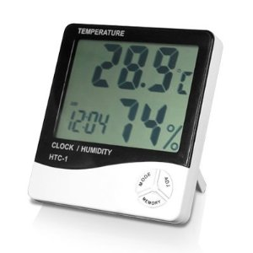

Step 1
Buy this meter. (was £5.44 incl.
postage from Amazon)
Type HTC-1

Picture shows two values of interest :

- air temperature 28.9 ºC
- relative humidity 74 %

(also shows the time)

Step 2 Measure temperature and relative humidity on the patch, allowing meter say
15 minutes to stabilise.

Read values : for example, indicated temp = 20 ºC and relative humidity = 60%

Step 3 Use the chart below (or a larger version). On the horizontal axis, at the
indicated air temperature (20ºC), draw an imaginary vertical line up to
the line corresponding to the humidity (60%)
(it’s the 5th diagonal line down from 100% in steps of 10%)

Step 4 Read across to the l.h. vertical axis to get Dewpoint temperature = 12 ºC
Difference in these two temperatures is 20 – 12 = 8 ºC

Step 5 Multiply this difference by 400 to get cloudbase start altitude i.e. 3200 ft.

(Use eye to estimate for values of humidity between the 10% lines)
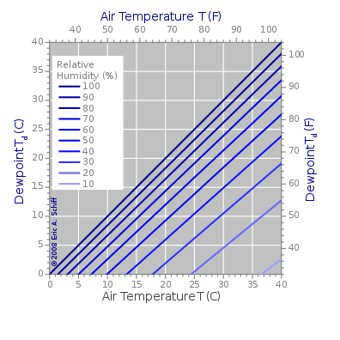

A larger version of this chart is
included with these notes.

